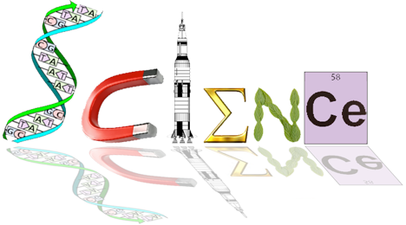

**Human Biology Year 12**

**Task 2: Endocrine and Nervous System Test**

**Name: Date: /65**

**Multiple Choice Section: (20 marks)**

1. The cerebral cortex is mainly concerned with which of the following?
2. connecting the left and right hemispheres
3. conscious sensory awareness and voluntary movement
4. control of the endocrine system
5. control of both the parasympathetic and sympathetic nervous systems
6. Which of the following statements concerning a spinal reflex is NOT correct?
7. it is a rapid process
8. it is involuntary
9. it can bypass the brain
10. it can occur in a different manner each time
11. Within the nervous system there are special structures that help to protect the system from injury. The name of the membranes that surround the central nervous system is the:
12. meniscus
13. meninges
14. medulla
15. myelin
16. People who have suffered physical damage to the cerebellum would be expected to show symptoms such as:
17. a low intelligence
18. uncoordinated jerky movements
19. a lack of autonomic nervous system functioning
20. no memory
21. The autonomic nervous system is responsible for which of the following?
22. sleeping and waking cycles
23. voluntary smooth muscle functioning
24. involuntary smooth muscle functioning
25. voluntary skeletal muscle functioning

The information below describes changes that occur within the human body

1. dilation of pupils
2. increased salivation
3. increased secretion from the sweat glands
4. increased heart rate
5. decreased levels of adrenalin
6. dilation of blood vessels in the skeletal muscle
7. Which of the changes described above occur as a result of stimulation of the sympathetic nervous system?
8. (i), (iii), (v) and (vi)
9. (i), (ii), (iii) and (v)
10. (i), (iii), (iv) and (vi)
11. (ii), (iv), (v) and (vi)
12. The effectors associated with negative feedback models are:
13. the nervous and endocrine systems
14. the body fluids
15. glands and muscles
16. all body tissues
17. The ________ contains centres for heartbeat, breathing, and blood pressure.
18. hypothalamus
19. cerebellum
20. medulla oblongata
21. spinal cord
22. Which of the following is NOT produced by the anterior pituitary gland?
23. antidiuretic hormone
24. thyroid stimulating hormone
25. growth hormone
26. prolactin
27. Which of the following statements is true of hormones?
28. Hormones are stable, long-lasting chemicals released from glands
29. All hormones are lipid-soluble
30. Hormones are chemical messengers that are released into interstitial fluid
31. Hormones are short-lasting and function in localised areas of the body
32. When the hormone cortisol reaches a target cell, it enters the cell and combines with a receptor protein inside the cell. The combined substance enters the nucleus, where it activates genes to produce a protein. Thus, cortisol is a:
33. water soluble amine
34. water soluble steroid
35. lipid soluble amine
36. lipid soluble steroid
37. The nervous and endocrine systems are both important in the coordination of body functions. However, there are several differences in their modes of action.

Which one of the following statements concerning these differences is correct?

1. Hormones take milliseconds to reach their target, whereas nerve impulses take longer, ranging from seconds to hours.
2. Once they have reached their target, hormonal responses last for longer periods of time than nervous responses.
3. Hormonal responses involve electrochemical changes, whereas nervous responses involve only chemical changes.
4. Nervous responses are usually more general and widespread than hormonal responses.

Question 13 refers to the diagram below.



1. The region labelled ‘X’ represents a
2. ganglion
3. node of Ranvier
4. neuromuscular junction
5. synapse

Question 14 and 15 refers to the diagram below.

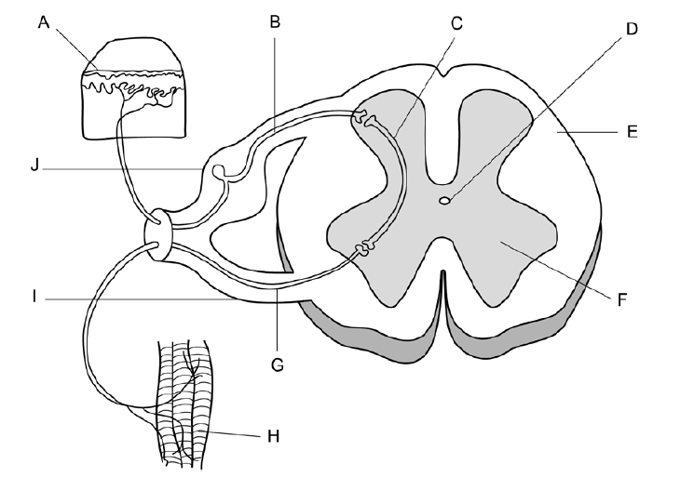

1. Which of the following statements relating to the above diagram of the spinal reflex arc is correct?
2. A stimulus is detected by the receptors labelled ‘H’ and transmitted through the sensory neuron labelled ‘G’
3. The motor neuron is labelled ‘G’ and is located in the ventral root labelled ‘I’
4. The interneuron is labelled ‘C’ and is located in the white matter labelled ‘F’
5. A stimulus is detected by the receptors labelled ‘A’ and transmitted through the motor neuron labelled ‘B’
6. The neuron labelled ‘B’ in the diagram can be described as an:
7. afferent neuron carrying information toward the spinal cord
8. efferent neuron carrying information away from the spinal cord
9. efferent neuron carrying information toward the spinal cord
10. afferent neuron carrying information away from the spinal cord

Question 16 refers to the diagram below

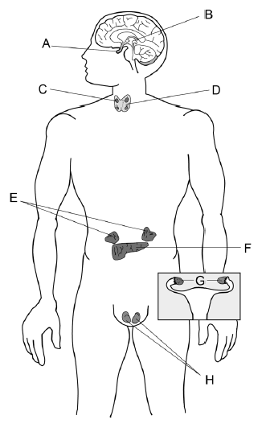

1. Which of the following options correctly matches a label with a hormone it secretes?
2. A = melatonin
3. D = growth hormone
4. E = adrenaline
5. H = oxytocin
6. In a person with normal thyroid function, low levels of thyroxin in the blood would result in:
7. increased metabolic rate and would involve feedback from the anterior pituitary
8. increased metabolic rate and would involve feedback from the posterior pituitary
9. decreased metabolic rate and would involve feedback from the anterior pituitary
10. decreased metabolic rate and would involve feedback from the posterior pituitary
11. Throughout the peripheral nervous system _______________ cells produce myelin, whereas ___________________ provide myelin in the central nervous system.
12. astrocytes, Schwann
13. Schwann, oligodendrocytes
14. Schwann, neurilemma
15. neurilemma, astrocytes
16. Which of the following structures is the smallest?
17. nerve
18. neuron
19. nerve fibre
20. ganglion
21. At resting potential, the ion distribution inside and outside of a neuron is such that __________ ions are most abundant on the outside of the cell, while __________ ions are most abundant on the inside of the cell.
22. potassium; sodium
23. sodium; potassium
24. calcium; phosphate
25. sulfate; potassium

**YEAR 12 ATAR HUMAN BIOLOGY**

**Task 2:**

**Endocrine and Nervous System Test**

**NAME:_____________________________**

**TEACHER:__________________________**

**DATE:______________________________**

**Multiple choice section**

Answer all questions by circling the most correct answer on the multiple choice answer sheet.

1. a b c d 11. a b c d

2. a b c d 12. a b c d

3. a b c d 13. a b c d

4. a b c d 14. a b c d

5. a b c d 15. a b c d

6. a b c d 16. a b c d

7. a b c d 17. a b c d

8. a b c d 18. a b c d

9. a b c d 19. a b c d

10. a b c d 20. a b c d

SCORES:

MC: /20

SA: /25

EA: /20

TOTAL: /65

_______ %

**Short Answer Section: 25 marks**

**Answer all questions**

21a. Complete the following table comparing the Autonomic and Somatic Nervous Systems, provide two differences between the divisions. (4 marks)

|  |  |  |
| --- | --- | --- |
|  | **Autonomic** | **Somatic** |
| **Difference 1** |  |  |
| **Difference 2** |  |  |

21b. Explain why scientists classify neurons into both functional and structural types. (2 marks)

________________________________________________________________________________________________________________________________________________________________________________________________________________________________________________________________________________________________________________________

One of the types of neurons involved in the reflex arc is classified as unipolar.

The diagram below shows the general structure of a unipolar neuron.



21c. Name the type of neuron that is pseudounipolar. (1 mark)

______________________________________________________________________________

21d. Explain why it is classified as pseudounipolar. (1 mark)

__________________________________________________________________________________________________________________________________________________________________________________________________________________________________________

22. The diagram below shows the relationship between the hypothalamus and the pituitary gland.





22a. Describe the process leading to secretion of hormones from the anterior lobe into the bloodstream. (3 marks)

________________________________________________________________________________________________________________________________________________________________________________________________________________________________________________________________________________________________________________________

22b. Explain why the posterior lobe is not considered to be a true endocrine gland. (2 marks)

________________________________________________________________________________________________________________________________________________________________________________________________________________________________________________________________________________________________________________________

22c. Use the two hormones released by the anterior lobe of the pituitary gland to complete the following table. (4 marks)

|  |  |  |
| --- | --- | --- |
| **Hormone** | **Target Cells/Organ** | **Function** |
| **Adrenocorticotrophic**  **hormone (ACTH)** |  |  |
| **Luteinizing hormone**  **(LH)** |  |  |

23. Refer to the following diagram for question 23.



23a. Alzheimer’s disease is a form of dementia that can cause memory loss, confusion and mood swings. Given these symptoms of Alzheimer’s disease, which part of the brain

(labelled A-D) above would you expect to be most affected by this disease? (1 mark)

______________________________________________________________________________

23b. Although different diseases, Alzheimer’s disease and Parkinson’s disease are similar in that they both affect the brain. There are also similarities in the causes and effects of these diseases.

State one such similarity between Alzheimer’s disease and Parkinson’s disease. (1 mark)

____________________________________________________________________________________________________________________________________________________________

23c. Complete the table below, describing 3 key differences between the nervous and endocrine system. (6 marks)

|  |  |  |
| --- | --- | --- |
| **Characteristic** | **Nervous System** | **Endocrine System** |
| Nature of Message |  |  |
|  |  | All body cells |
|  | Usually local and specific |  |

**Extended Answer Section: 20 marks**

Answer each part of the following question on the lined paper provided. Responses could include clearly labelled tables and graphs, clearly labelled diagrams with explanatory notes, lists of points with linking sentences and annotated flow diagrams with introductory notes.

24a. Outline the events involved in an electrochemical nerve impulse travelling along an unmyelinated nerve fibre. (8 marks)

24b. Explain how this differs in a myelinated fibre. (4 marks)

When an impulse reaches the end of an axon it cannot travel any further as it has reached a gap called a synapse.

24c. Explain how an impulse can travel from one neurone to the next neurone; include the generalised role of neurotransmitters. (8 marks)